Ethan Johnson

COMP 4320

Assignment 1

Due 9/11/2020

1. A.) Given the information from the problem Circuit Switching would more appropriate to use in this scenario because the application is running for a continuously for a long period of time and I am assuming that the application is only being run by one user. Because of the irregular rate there would be more resources allocated than needed in some cases as the rate when using circuit switching is set up at the beginning which would be a downside but the length of time that the application will be running for makes up for that. Although the problem does not give this information if the application is sending to multiple destinations instead of just one destination that would also be a downside for using circuit switching.

B.) The link has plenty of capacity for the application, so no congestion control is necessary. The link offers 1.6 Mbps where the amount of data the application tries to transmit per second is 950 so unless multiple of the applications are trying to run simultaneously it would be unnecessary.

1. A.) 25 Users

B.) 20% or .2

C.) $\left(\begin{aligned}75 \\ k\end{aligned}\right)×{.2}^{k}{(1-.2)}^{(75-k)}$

D.) 0.002149

1. 19.1706 Milliseconds
2. A.) End to End Delay – ${k/T}_{1}+{k/T}_{2}+{k/T}_{3}+\frac{L_{1}}{p_{1}}+\frac{L_{2}}{p_{2}}+\frac{L_{3}}{p_{3}}+ t_{proc}+ t_{proc}$

B.) 0.09641 Seconds

1. .00464 Seconds
$$\frac{qk+\left(k-p\right)}{T}$$

2. A.) The transmission rate of a path S is made up of n links the answer is minimum($R_{1}^{S}$, $R_{2}^{S}$, …, $R_{n}^{S}$)

B.) Let the maximum throughput for a path be denoted by X and let *n* be the number of the path the answer is the highest maximum throughput of all possible paths denoted by max($X_{1}$, $X_{2 }$, … $X_{n}$)

A.) $\frac{TP}{R(1-T)}+\frac{P}{R}$ which is $\frac{P}{R(1-T)}$

B.) Let *x* by P/R then $\frac{x}{1-T}$ also *T* is equal to *xa* thus we get $\frac{x}{1-xa}$ which then graphs to

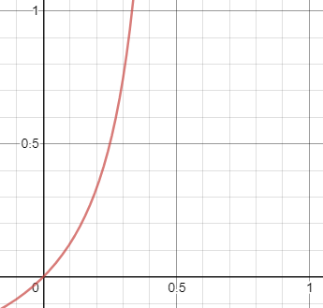

C.) $\frac{\frac{P}{R}}{1-\frac{αP}{R}}$ which then turns into $\frac{P}{R(1-\frac{αP}{R})}$ which after reducing and plugging in $ρ$ for R we get the final answer which is $\frac{P}{ρ-αP}$

1. A.) 1.2 Seconds

B.) The first packet reaches the first switch after 0.0002 seconds and the second packet reaches the first switch at 0.0004 seconds

C.) .4004 seconds, segmentation is much faster

D.) The message has to be assembled at the destination and as you pass through different layers and protocols there will be additional header information add to each individual packet causing for greater size to transmit than the original message